Bank Loan Report Query Document

KPI’s

Total Loan Application

select count(id) as Total_applications from financial_loan



Month to date loan applications

select count(id) as MTD_Total_applications from financial_loan

where MONTH(issue_date) = 12 and year(issue_date) = 2021



select count(id) as PMTD_Total_applications from financial_loan

where MONTH(issue_date) = 11 and year(issue_date) = 2021



Total Funded Amount

select sum(loan_amount) as Total_funded_amount from financial_loan



MTD_Total_funded_amount

select sum(loan_amount) as MTD_Total_funded_amount from financial_loan

where month(issue_date) = 12 and year(issue_date) = 2021



select sum(loan_amount) as PMTD_Total_funded_amount from financial_loan

where month(issue_date) = 11 and year(issue_date) = 2021



Total Received amount

select sum(total_payment) as Total_amount_received from financial_loan



select sum(total_payment) as MTD_Total_amount_received from financial_loan

where month(issue_date) = 12 and year(issue_date) = 2021



select sum(total_payment) as PMTD_amount_received from financial_loan

where month(issue_date) = 11 and year(issue_date) = 2021



Interest Rate

select round(AVG (int_rate), 4)*100 as Avg_Interest_rate from financial_loan



select Round(avg (int_rate), 4) *100 as MTD_AVG_Interest_rate from financial_loan

where month(issue_date) = 12 and year(issue_date) = 2021



select round(Avg (int_rate), 4) *100 as PMTD_Avg_Interest_rate from financial_loan

where month(issue_date) = 11 and year(issue_date) = 2021



Debt

select round(Avg(dti), 4)*100 as Avg_dti from financial_loan



select round(Avg(dti), 4)*100 as MTD_Avg_dti from financial_loan

where month(issue_date) =12 and year(issue_date) = 2021



select round(Avg(dti), 4)*100 as PMTD_Avg_dti from financial_loan

where month(issue_date) =11 and year(issue_date) = 2021



--- Problem statement -- Good loan Bad Loan , Dashboard - 1

select

(count(case when loan_status = 'Fully Paid' or loan_status= 'Current' then id end) *100)

/

count(id) as good_loan_percentage

from financial_loan



select count(id) as Good_loan_applications from financial_loan

where loan_status = 'Fully Paid' or loan_status = 'Current'



select sum(loan_amount) as Good_loan_amount from financial_loan

where loan_status = 'Fully Paid' or loan_status = 'Current'



select sum(total_payment) as Good_loan_received_amount from financial_loan

where loan_status = 'Fully Paid' or loan_status = 'Current'



**Bad Loan**

select count(id) as Bad_loan_applications from financial_loan

where loan_status = 'Charged Off'



select

(count(case when loan_status = 'Charged Off' then id end )* 100.0)/

count(id) As Bad_loan_percentage

from financial_loan



Bad Loan Amount

select sum(loan_amount) as Bad_loan_amount from financial_loan

where loan_status = 'Charged Off'



select sum(total_payment) as Bad_loan_amount_received from financial_loan

where loan_status = 'Charged Off'



Loan Status for Multiple Division

select

loan_status,

count(id) as Total_Loan_applications,

sum(total_payment) as total_amount_received,

sum(loan_amount) as total_funded_amount,

avg(int_rate*100) as Interest_rate,

avg(dti *100) as DTI

from

financial_loan

group by

loan_status

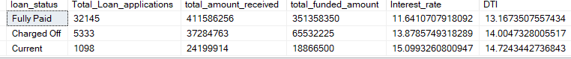

For current month Loan Status

select loan_status,

sum(total_payment) as MTD_Total_amount_received,

sum(loan_amount) as MTD_Total_funded_amount

from financial_loan

where month(issue_date) = 12

group by loan_status

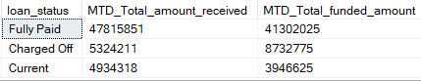

Dashboard – 2 Overview

select

month(issue_date) as month_number,

datename(month,issue_date) as month_name,

count(id) as total_loan_applications,

sum(loan_amount) as total_funded_amount,

sum(total_payment) as total_received_amount

from financial_loan

group by month(issue_date) , datename(month,issue_date)

order by month(issue_date)

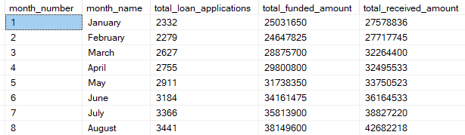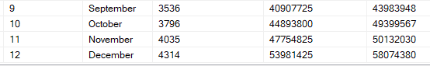

select

address_state,

count(id) as total_loan_applications,

sum(loan_amount) as total_funded_amount,

sum(total_payment) as total_received_amount

from financial_loan

group by address_state

order by count(id) desc

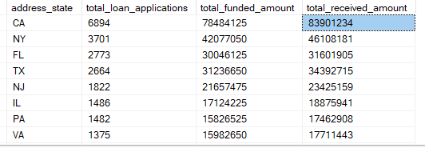

select

term,

count(id) as total_loan_applications,

sum(loan_amount) as total_funded_amount,

sum(total_payment) as total_received_amount

from financial_loan

group by term

order by term

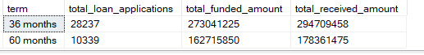

select

emp_length,

count(id) as total_loan_applications,

sum(loan_amount) as total_funded_amount,

sum(total_payment) as total_received_amount

from financial_loan

group by emp_length

order by count(id) desc

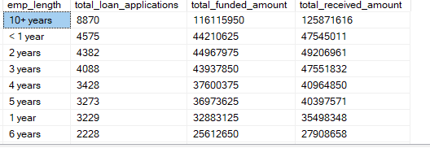

select

purpose,

count(id) as total_loan_applications,

sum(loan_amount) as total_funded_amount,

sum(total_payment) as total_received_amount

from financial_loan

group by purpose

order by count(id) desc

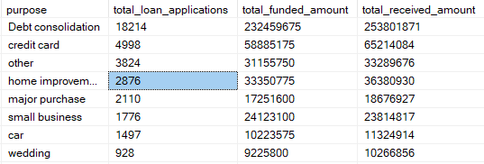

select

home_ownership,

count(id) as total_loan_applications,

sum(loan_amount) as total_funded_amount,

sum(total_payment) as total_received_amount

from financial_loan

group by home_ownership

order by count(id) desc

